Grade 2 STEM – Electricity CBQ
1. Scenario-Based
Riya connects a battery, bulb and wires. The bulb glows. Why?
A. Electricity flows through a complete circuit
B. Bulb is colourful
C. Wire is long
D. Battery is heavy

2. Scenario-Based
Tarun wants to touch an electric switch after washing his hands. What should he do first?
A. Switch on immediately
B. Dry his hands
C. Pour more water
D. Use metal objects

3. Scenario-Based
A toy car stops moving when its battery is removed. What does this show?
A. Electricity helps devices work
B. Batteries are toys
C. Wires make sound
D. Bulbs store power

4. Scenario-Based
Meera chooses copper wire for a circuit. Why?
A. Copper is a conductor
B. Copper is an insulator
C. Copper is soft
D. Copper is transparent

5. Scenario-Based
A child wears rubber slippers near electrical equipment. Why?
A. Rubber is colourful
B. Rubber is an insulator
C. Rubber stores electricity
D. Rubber glows

6. Scenario-Based
An LED glows when connected properly. What does this indicate?
A. Circuit is complete
B. Battery is empty
C. Wire is broken
D. Switch is damaged

7. Case-Based
Aman notices a damaged electric cord at home. What should be done?
A. Continue using it
B. Replace it safely
C. Put it in water
D. Ignore it

8. Case-Based
Sara finds a complex electrical fault at home. What is the safest action?
A. Repair it alone
B. Ignore it
C. Call an electrician
D. Touch the wires

9. Data-Based
Table: Copper-Conductor, Plastic-Insulator, Steel-Conductor. Which material is an insulator?
A. Copper
B. Plastic
C. Steel
D. Aluminium

10. Data-Based
Table: Bulb-Needs Electricity, Computer-Needs Electricity, Notebook-Does Not Need Electricity. Which item does not need electricity?
A. Bulb
B. Computer
C. Notebook
D. LED

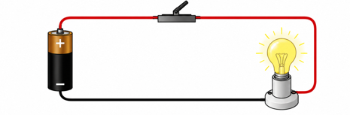
11. Picture-Based
A picture shows a battery connected to a bulb with wires and the bulb is glowing. What is shown?
A. Open circuit
B. Electric circuit
C. Water cycle
D. Network

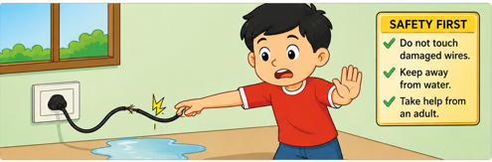
12. Picture-Based
A picture shows a person wearing rubber gloves while handling electrical equipment. Why?

A. Decoration
B. Safety from electricity
C. Fashion
D. To increase power

13. Assertion–Reason
Assertion: Conductors allow electricity to pass through them. Reason: Copper and aluminium are conductors.
A. Both true and reason explains
B. Both true but not explanation
C. Assertion true reason false
D. Both false

14. Assertion–Reason
Assertion: Water should be kept away from electrical devices. Reason: Water can cause electric shock.
A. Both true and reason explains
B. Both true but not explanation
C. Assertion true reason false
D. Both false

15. Assertion–Reason
Assertion: Rubber is used in electrical safety equipment. Reason: Rubber is an insulator and does not allow electricity to pass through easily.
A. Both true and reason explains
B. Both true but not explanation
C. Assertion true reason false
D. Both false

Answer Key
1-A
2-B
3-A
4-A
5-B
6-A
7-B
8-C
9-B
10-C
11-B
12-B
13-A
14-A
15-A

